**Lab 3: Video Mixing with Adobe Premier Pro**

**Objectives:**

This lab focused on video mixing using Adobe Premiere Pro, a professional video editing software widely used in multimedia production. The main task was to combine multiple video clips, audio tracks, and transition effects to create a smooth and engaging final video. Basic tools such as the timeline, razor tool, transitions, and audio mixer were used to cut, arrange, and enhance clips. The project helped in understanding how to manage multiple layers, synchronize video and audio, and apply visual effects. Overall, the lab provided practical experience in editing and mixing videos in a creative and organized way using Premiere Pro.

Steps:

1. create a new project to start our video mixing:

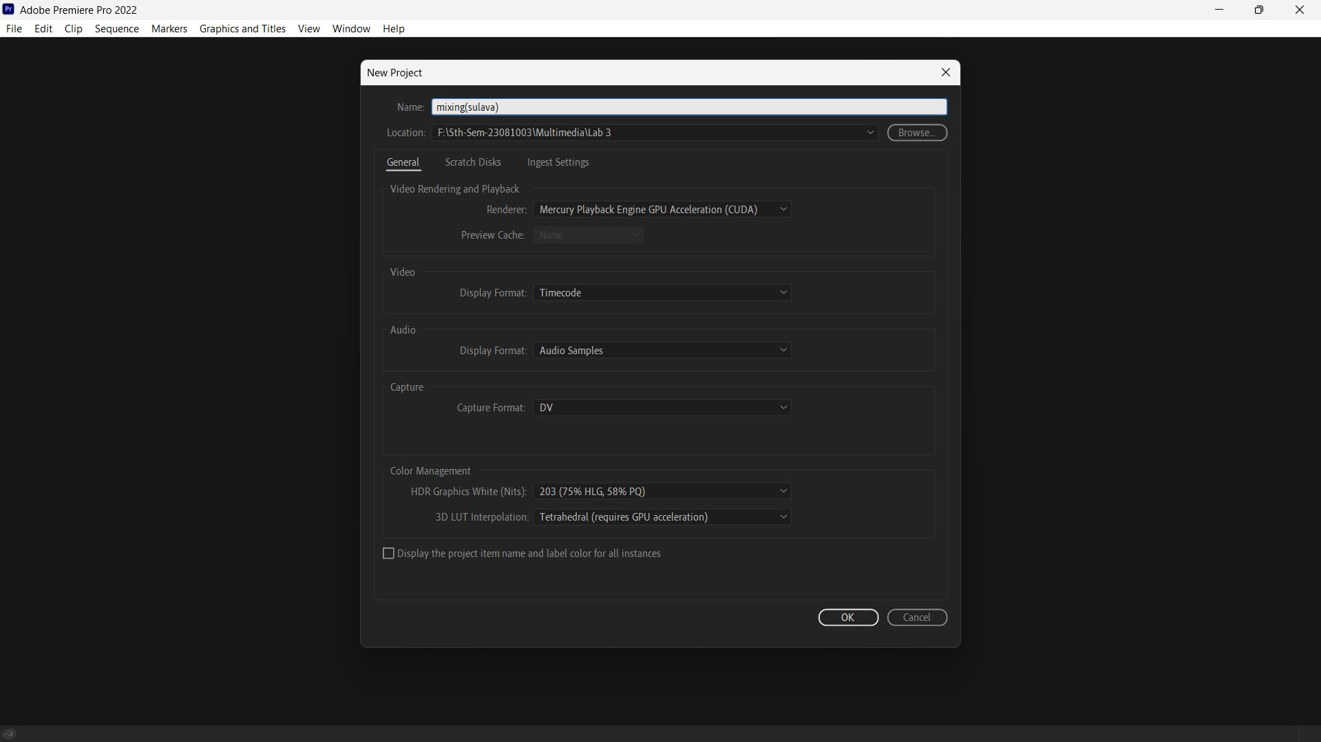

1. Import a media from the file:

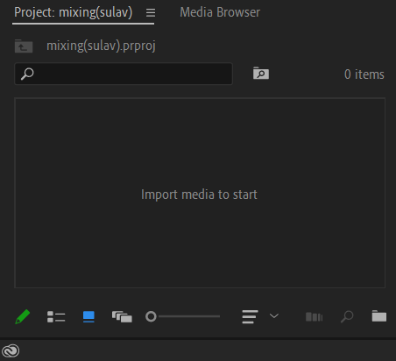

The imported media look like this:

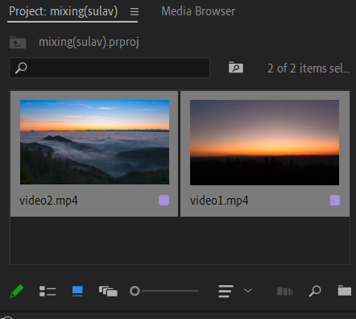

1. Now drag the video clip into the right side for grouping them:

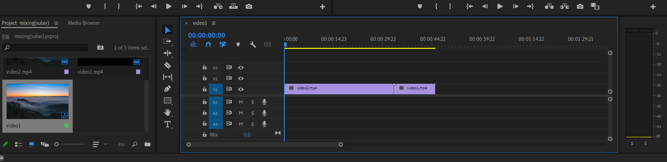

Then select the both clip and right click to group them:

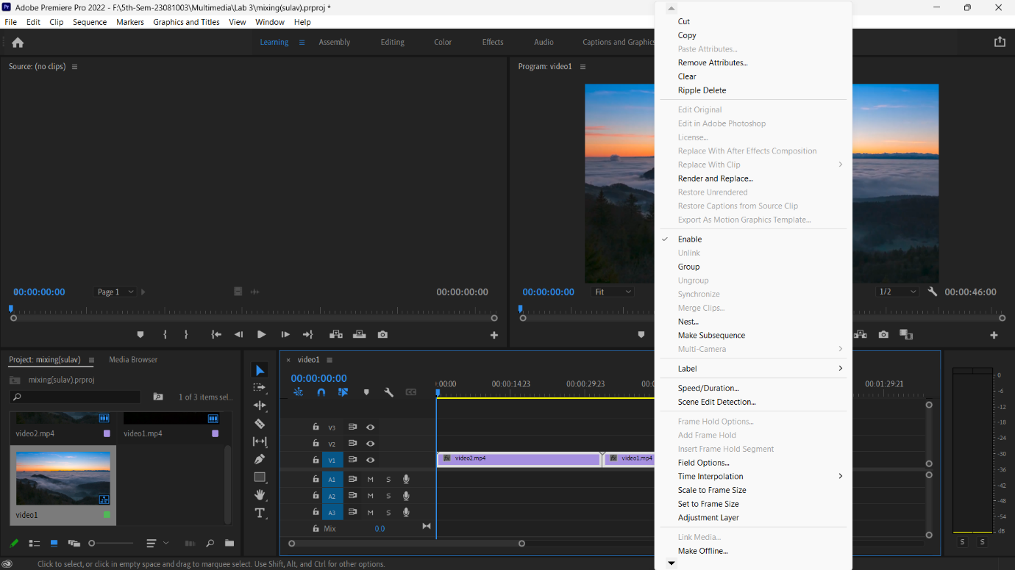

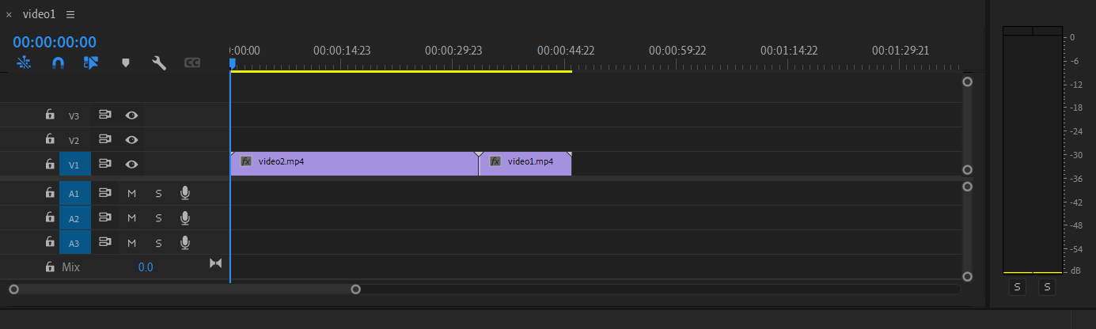 After grouping it will be a single video:

1. 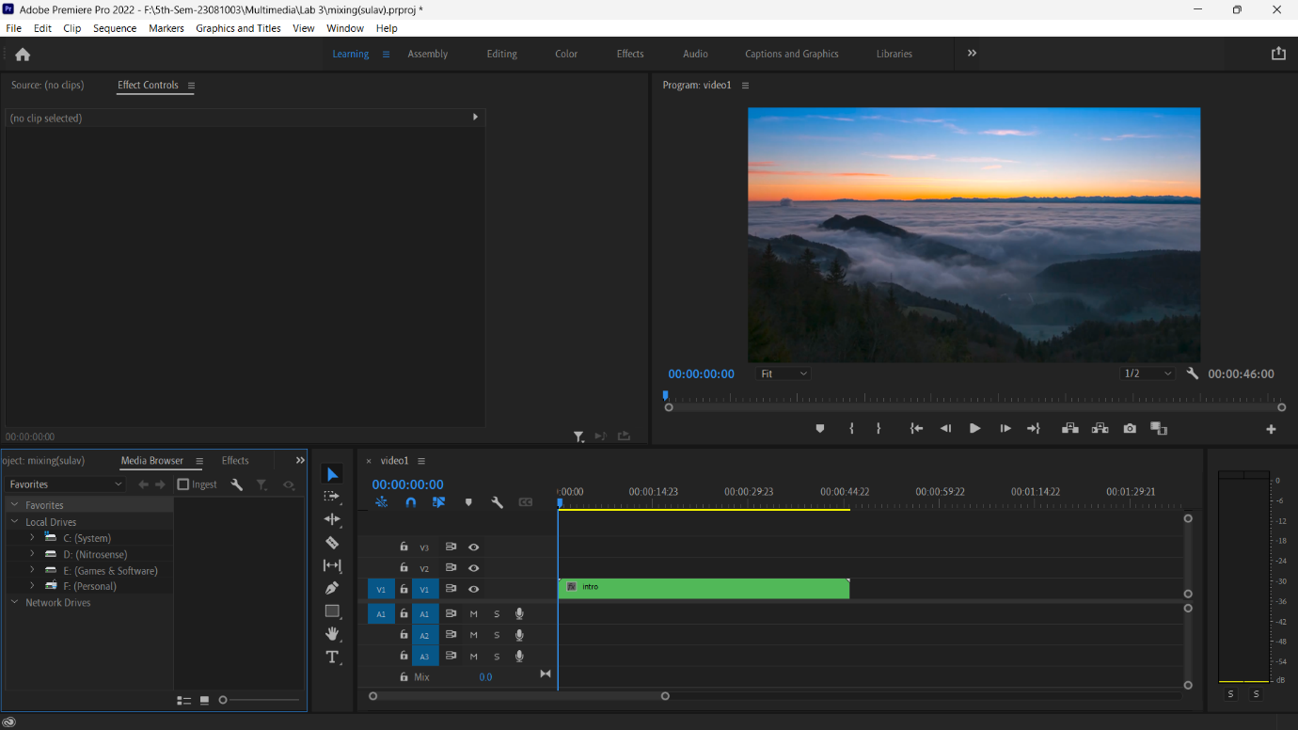After grouping the video, click the right button and then click nest:

We use the nest because it allows us to create a sequence within another sequence, treating the nested sequence as a single clip, which then can be manipulated and edited as one.

After nest it will be look like this:

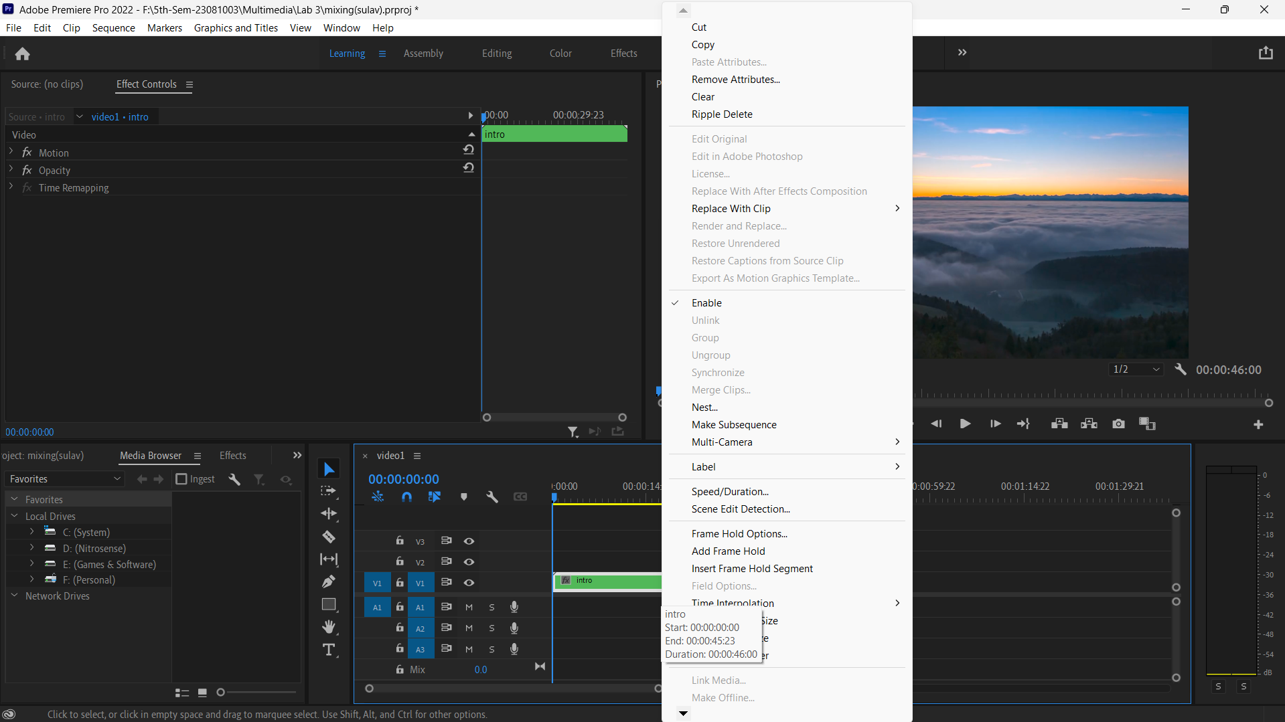

1. We can add effect to our nested video:

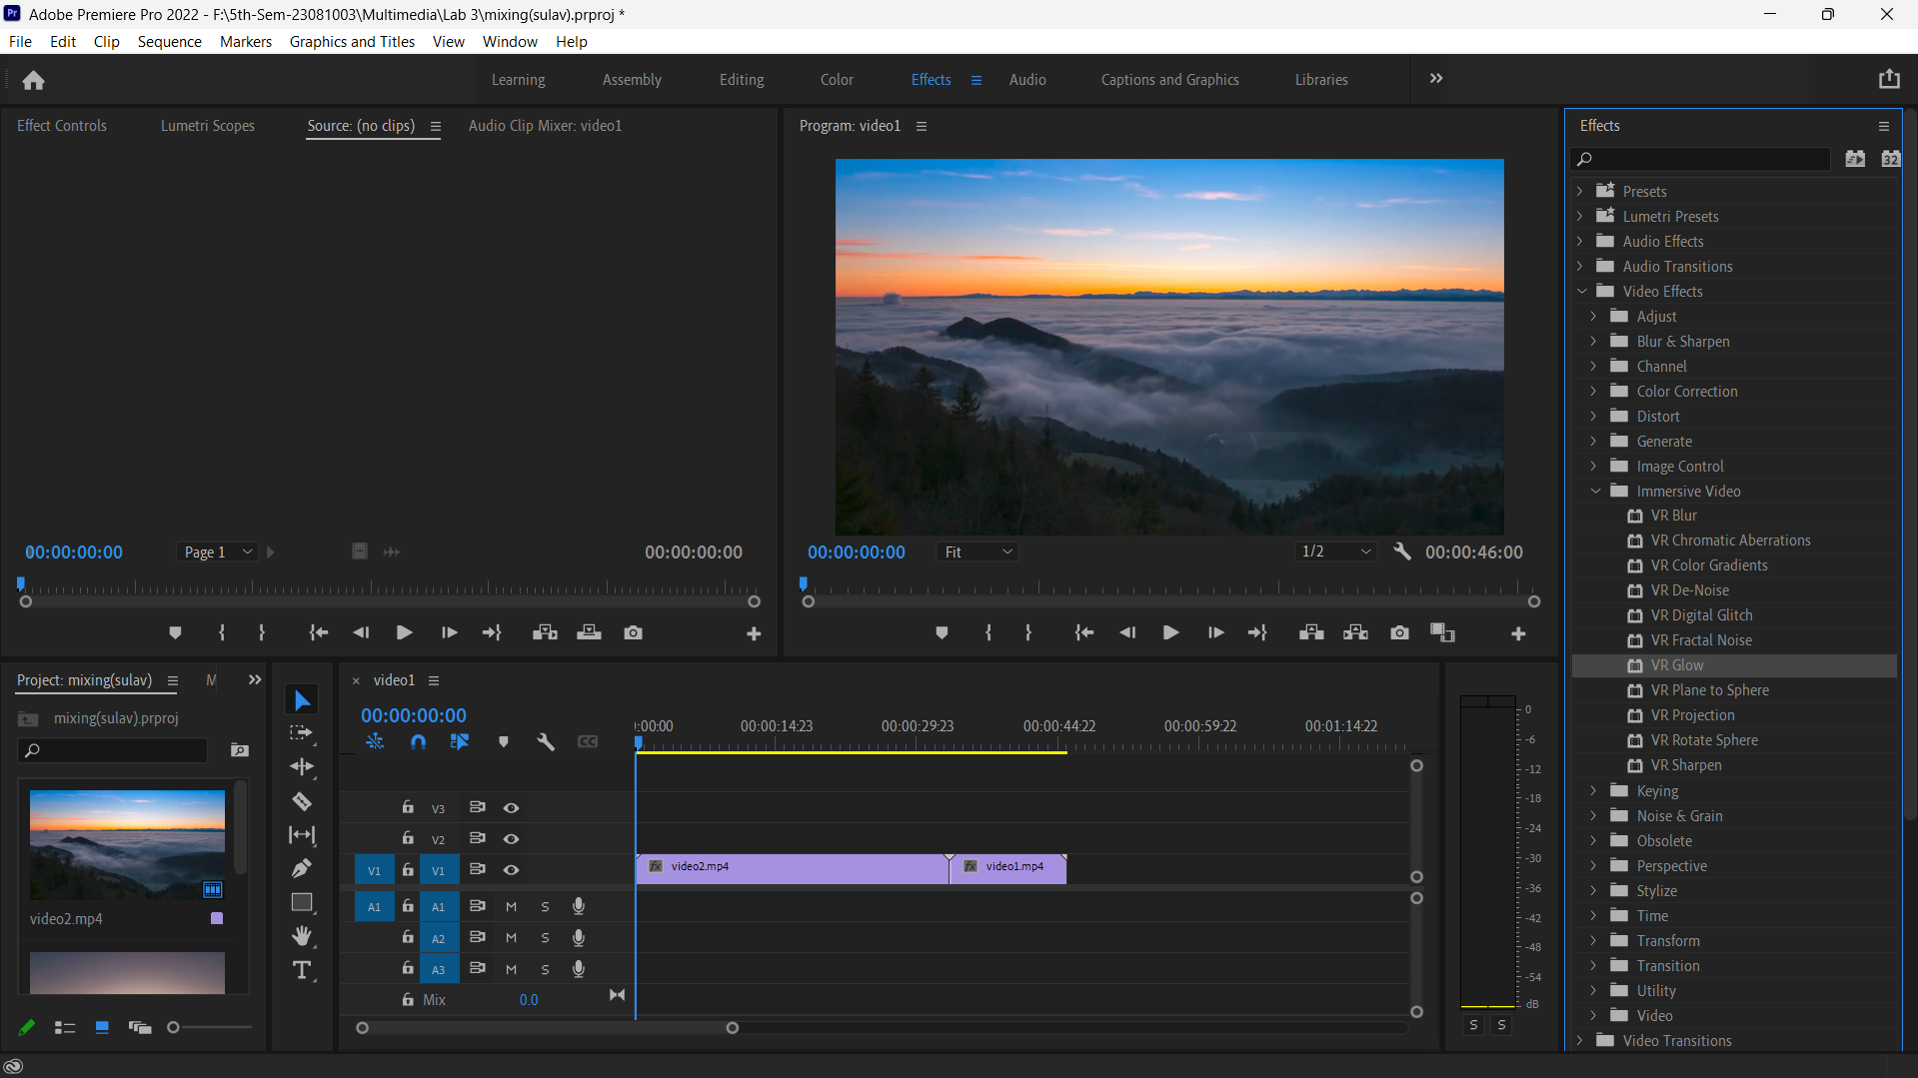

By dragging VR Glow to the video, we can add the effect. We can adjust the effect through effect controls:

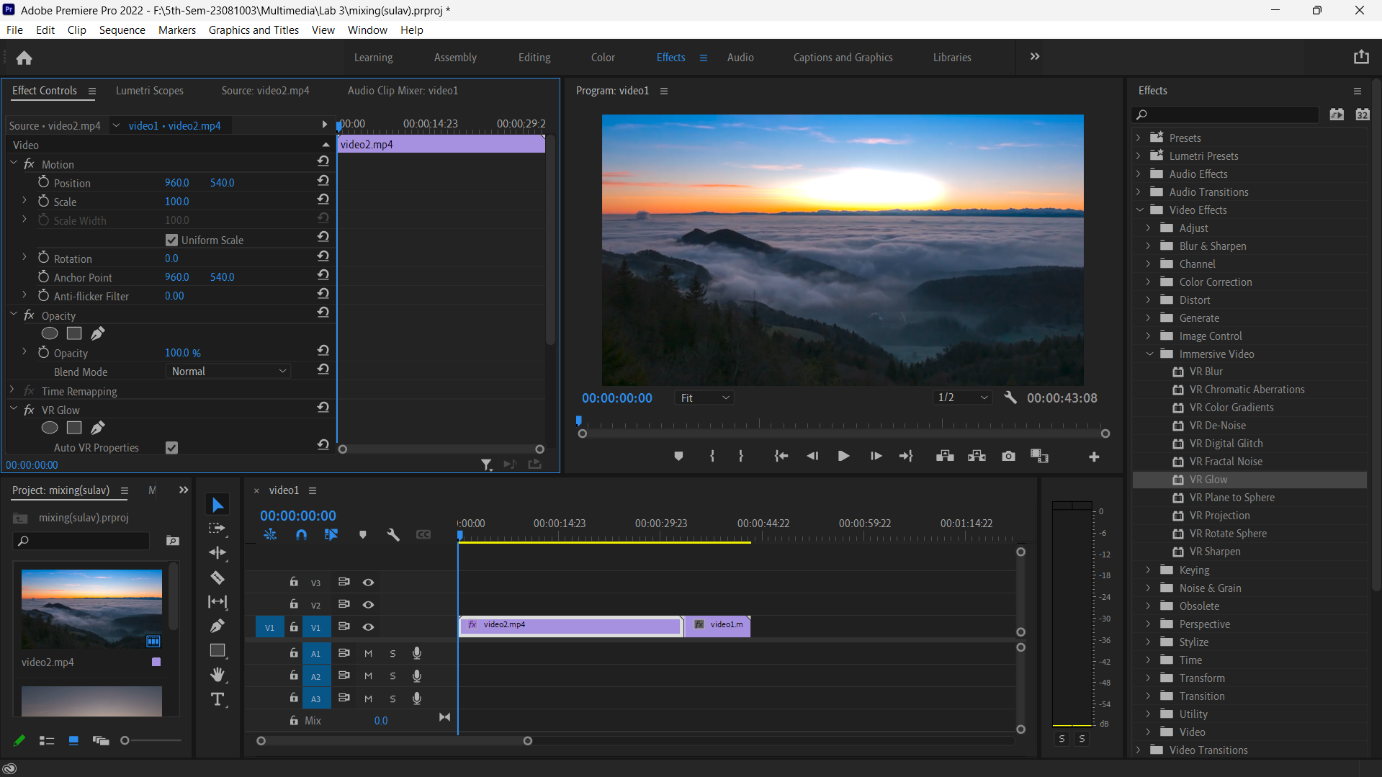

Finally, after adding effect our video is look like:

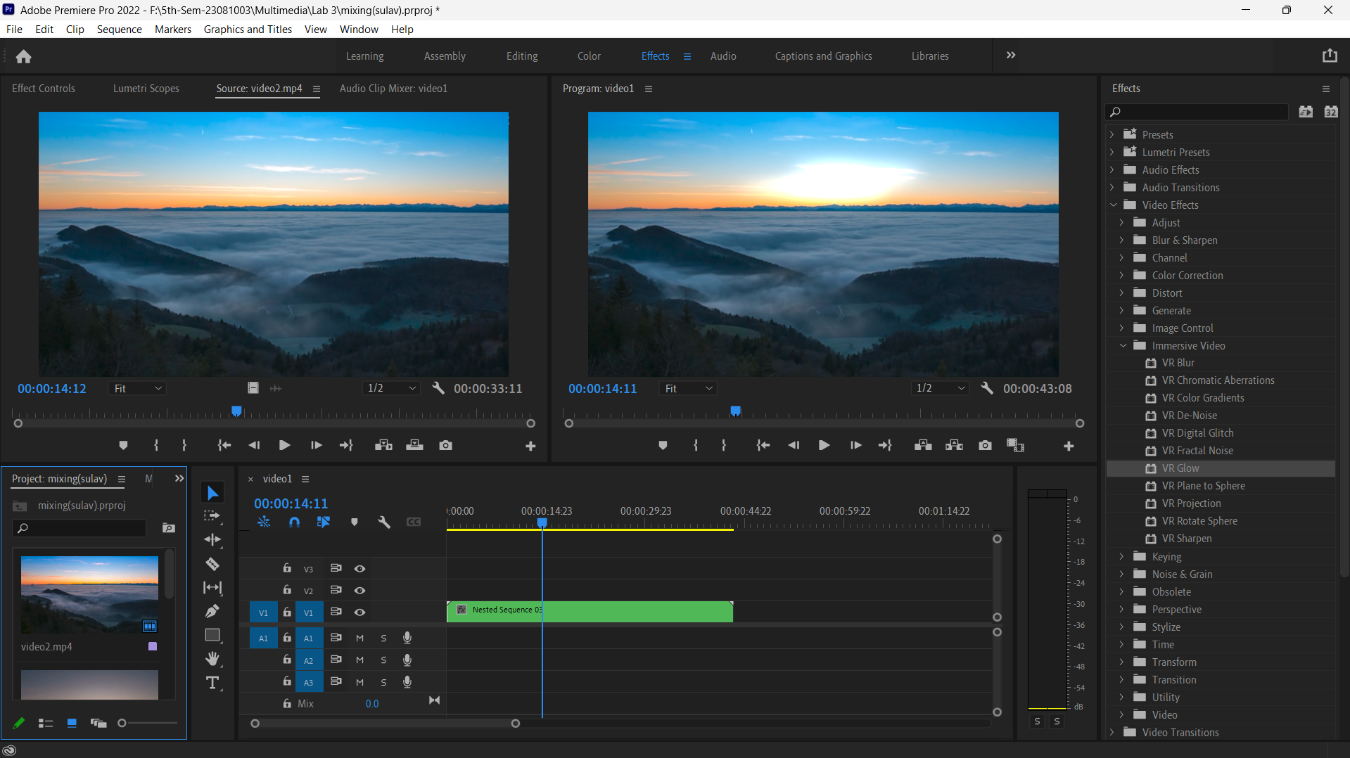

**Conclusion:**

In conclusion, the video mixing lab using Adobe Premiere Pro was a valuable experience in learning the basics of video editing. It helped in understanding how to combine different video and audio elements, apply transitions, and manage the editing timeline effectively. The hands-on practice improved the ability to create smooth and visually appealing videos, which is an important skill in multimedia production. This lab also built confidence in using professional editing tools and prepared for more advanced video editing tasks in the future.